
Assignment 01

Submitted by:
Afifa Arooj

Registration No:
FA24B1-SE-003

Submitted To:
Waqas Saleem

Course:
Cloud Computing

Section:
BSSE-V A

Assignment 01: Advanced Git Operations, Dual-Remote Synchronization, Git LFS, and Submodules

1. Executive Summary
This report documents the step-by-step execution and completion of Assignment01. The lab assignment covers:
- Local Git repository initialization and deployment on a self-hosted Gitea server.
- Dual-remote configuration (origin for Gitea and github for GitHub) and cloud synchronization using Personal Access Tokens (PAT).
- Installation and configuration of Git Large File Storage (Git LFS) to track and upload large binary files.
- Integration of external Git repositories using Git Submodules.

2. Task 1: Gitea Deployment & Repository Initialization

2.1 Description
A self-hosted Gitea instance was deployed on the local Ubuntu VM. A new repository named Assignment01 was created on Gitea, and local commits including README.md and basic workflow directory structures were pushed to the origin remote.

2.2 Execution Steps
Bash
# Initialize git repository
git init

# Add local commit
git add README.md
git commit -m "Add student information"

# Add Gitea as origin remote and push
git remote add origin http://192.168.184.129:3000/afifaarooj/Assignment01.git
git push -u origin main

2.3 Verification & Evidence
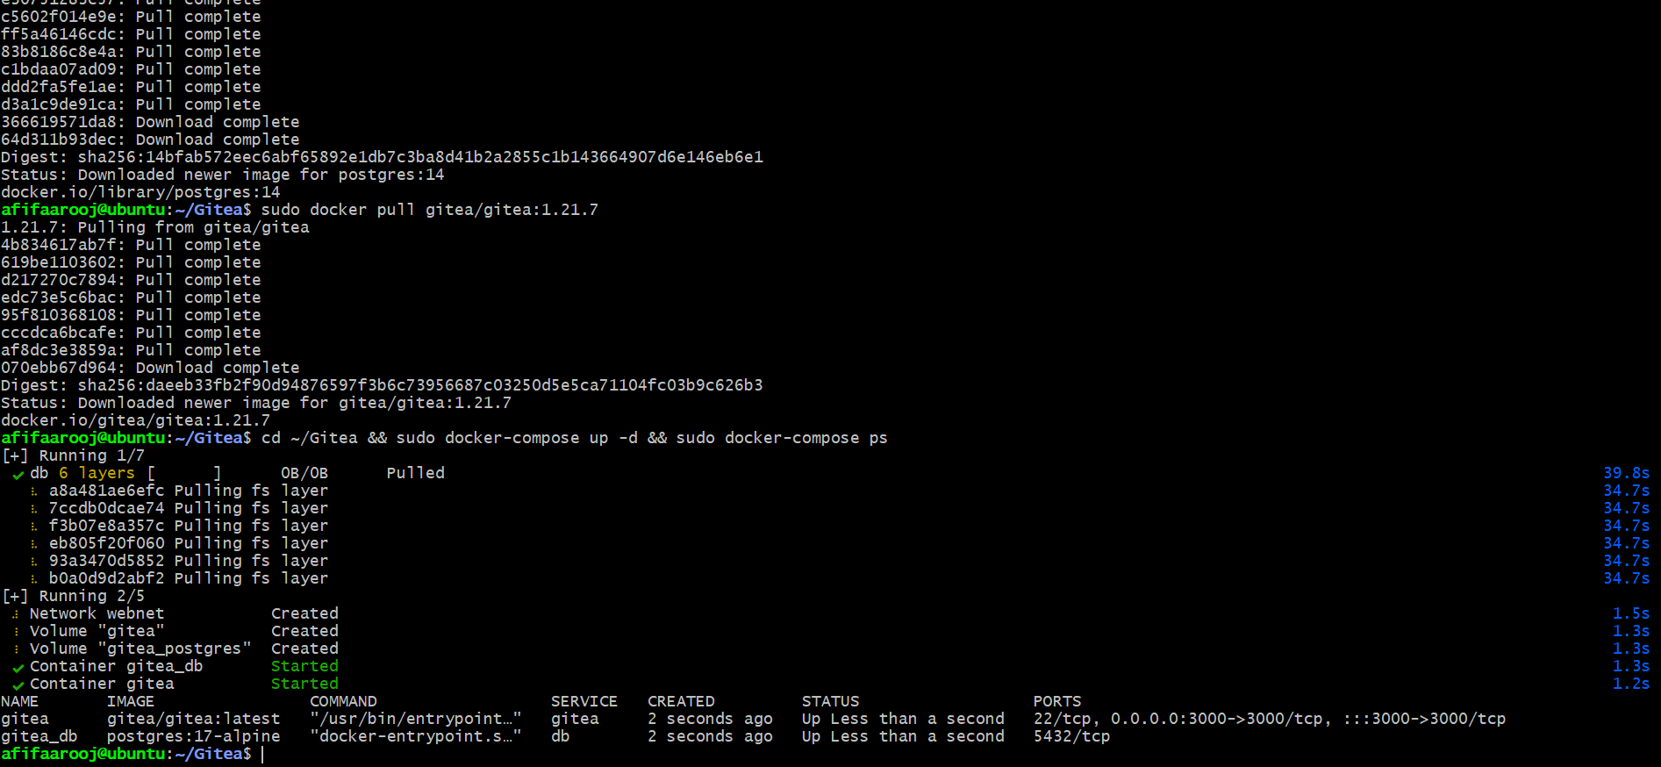
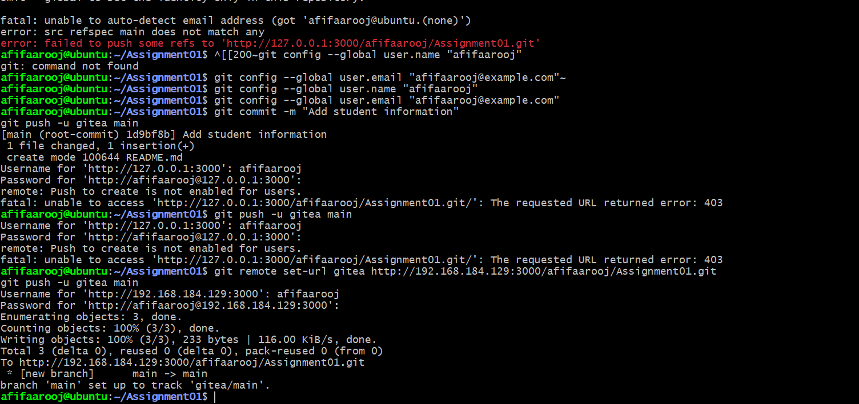
Task1_gitea_running.png
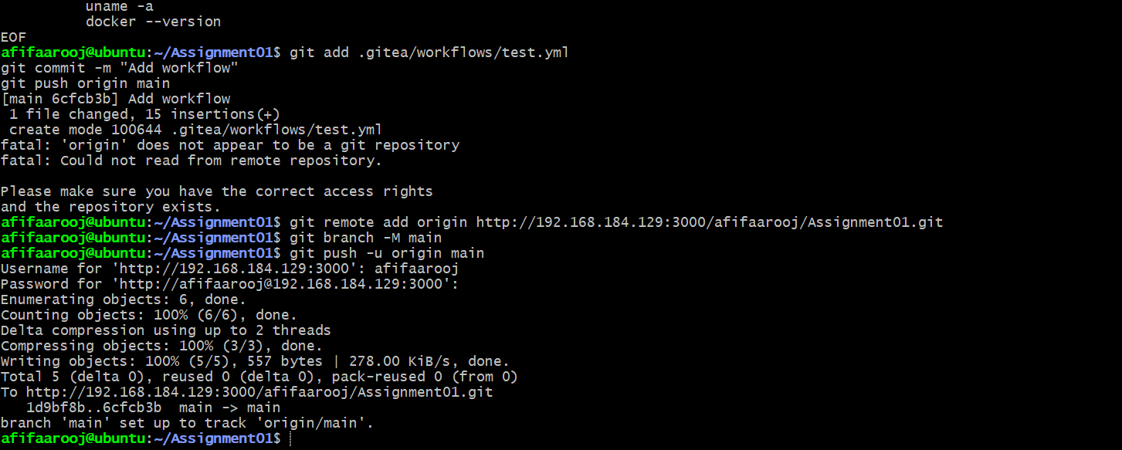
task1_gitea_push.png

task1_gitea_repository.png

3. Task 2: Dual Remote Setup & GitHub Synchronization

3.1 Description
To achieve dual-remote synchronization, a secondary remote named github was linked to the local repository. Authentication was successfully executed using a Personal Access Token (PAT) due to GitHub's password authentication restrictions.

3.2 Execution Steps
Bash
# Configure secondary GitHub remote
git remote add github https://github.com/afifaarooj/Assignment01.git

# Verify configured remotes
git remote -v

# Push main branch to GitHub using PAT authentication
git push -u github main

3.3 Verification & Evidence
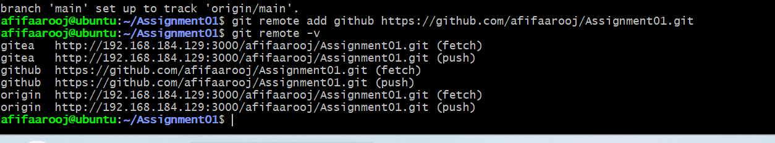
task2_remotes.png
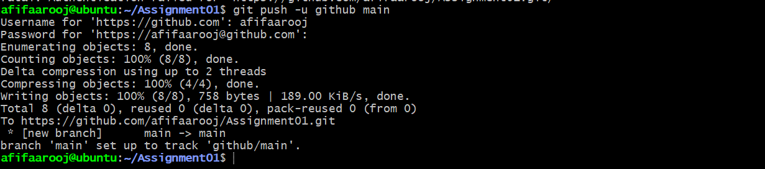
task2_github_push.png
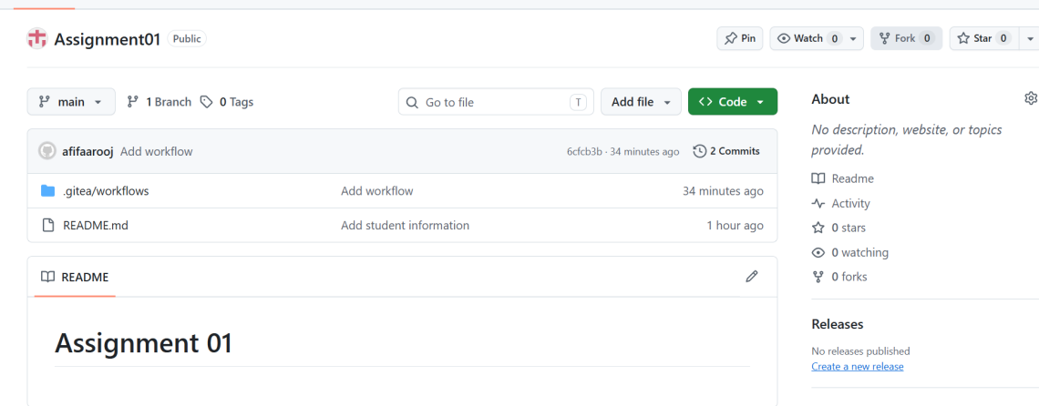
Task2_github_repository.png

4. Task 3: Track Three Large Files with Git LFS

4.1 Description
Standard Git repositories struggle with large binary files. Git LFS was installed and configured to track .bin binary files. Three dummy files (10MB each) were generated using the dd command, tracked via .gitattributes, committed, and pushed to the remote repository.

4.2 Execution Steps
Bash
# Install and initialize Git LFS
sudo apt update && sudo apt install git-lfs
git lfs install

# Generate three 10MB dummy files
dd if=/dev/zero of=file1.bin bs=1M count=10
dd if=/dev/zero of=file2.bin bs=1M count=10
dd if=/dev/zero of=file3.bin bs=1M count=10

# Configure LFS tracking pattern and stage attributes
git lfs track "*.bin"
git add .gitattributes

# Stage, commit, and push LFS tracked files
git add file1.bin file2.bin file3.bin
git commit -m "Add three large files tracked with Git LFS"
git push github main

4.3 Verification & Evidence
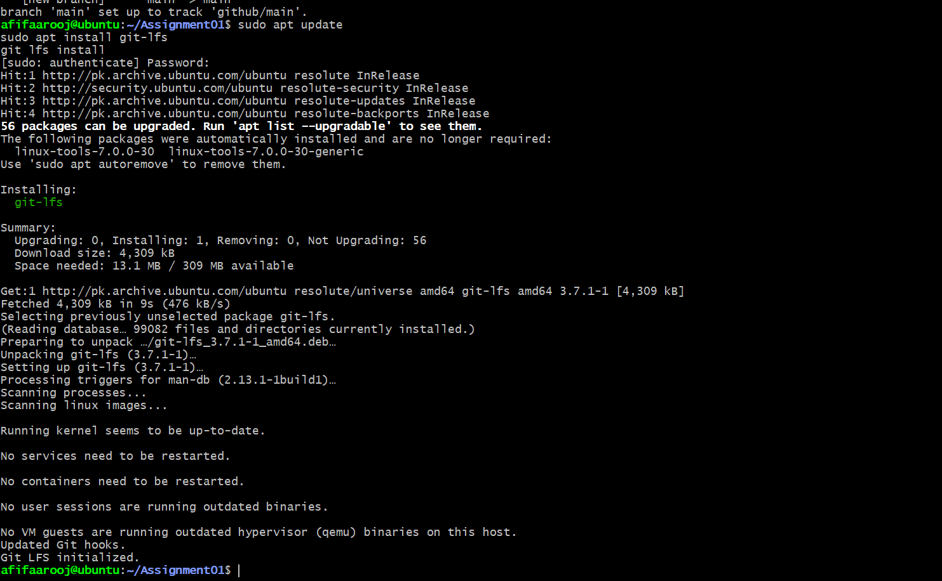
task3_lfs_install.png
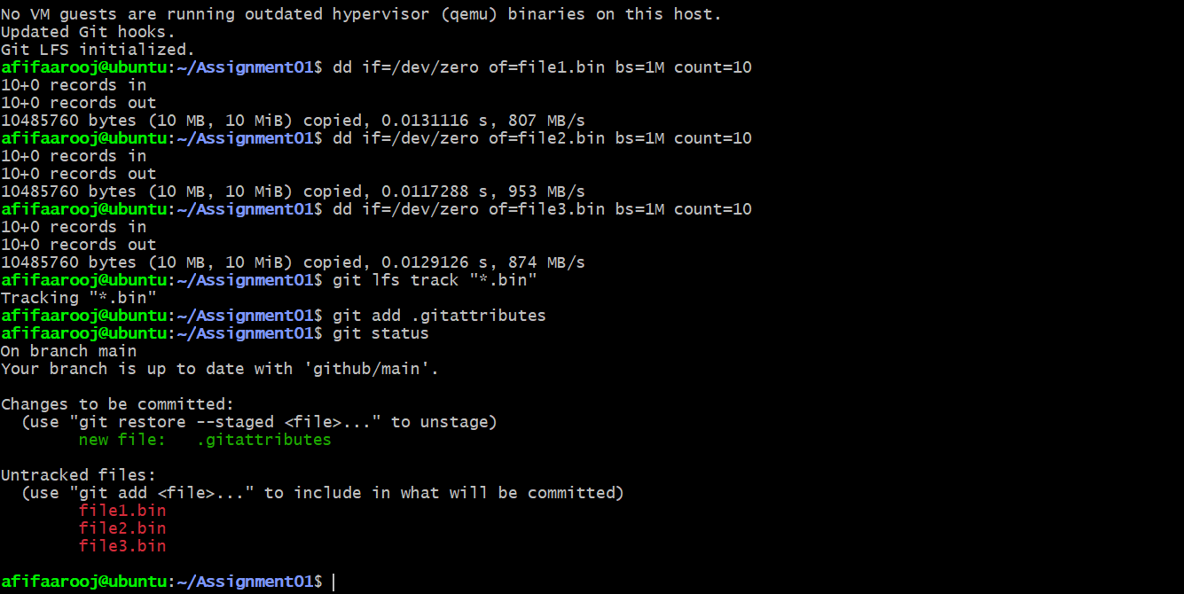
task3_lfs_track.png
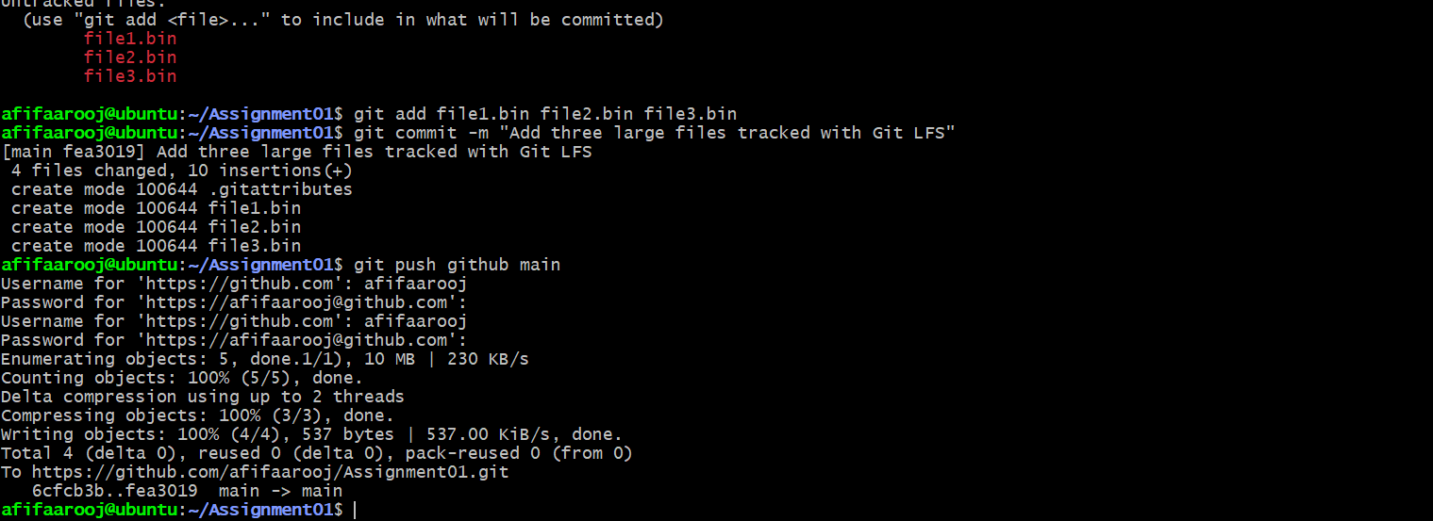
task3_lfs_push.png

5. Task 4: Git Submodule Integration

5.1 Description

To incorporate external dependencies cleanly without direct code copying, a public GitHub repository (octocat/Hello-World) was added as a Git Submodule inside the my-submodule directory. The submodule metadata (.gitmodules) was committed and synchronized.

5.2 Execution Steps
Bash
# Add public repository as a submodule
git submodule add https://github.com/octocat/Hello-world.git my-submodule

# Verify staging status
git status

# Commit submodule additions
git commit -m "Add Hello-World repository as a submodule"

# Push updates to GitHub remote
git push github main

5.3 Verification & Evidence
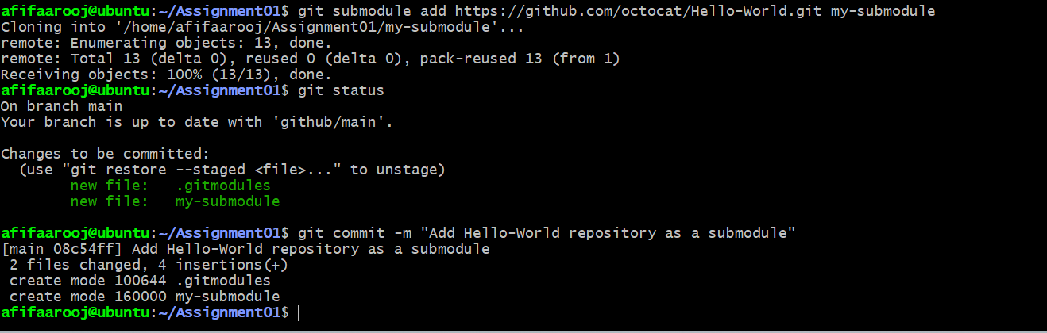
task4_submodule_add.png
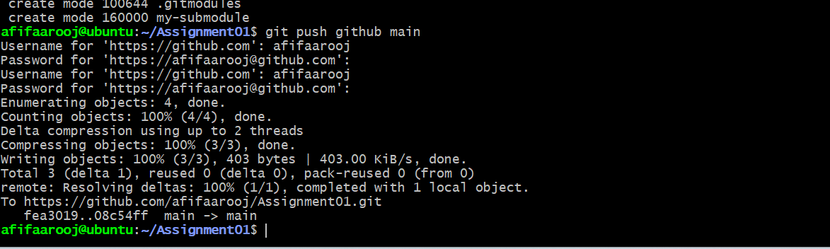
task4_submodule_push.png

6. Conclusion
All four core objectives specified in Assignment01 were successfully accomplished. The local repository is fully functional with dual remotes (Gitea and GitHub), binary tracking via Git LFS, and modular external linkage using Git Submodules.

